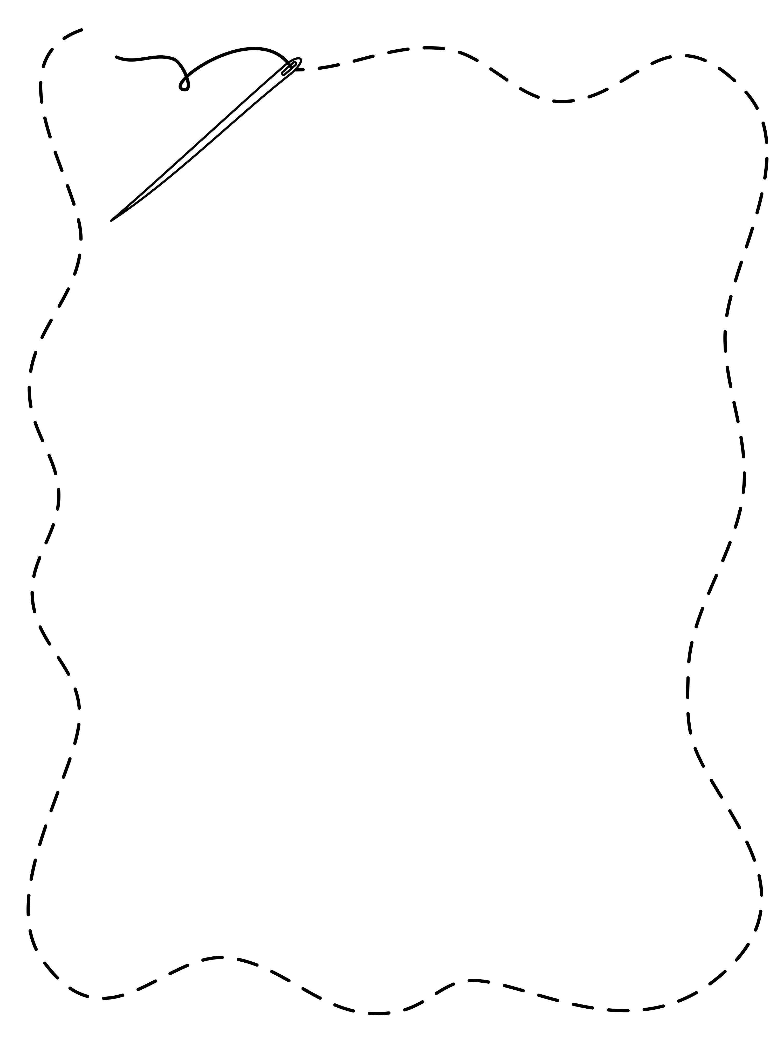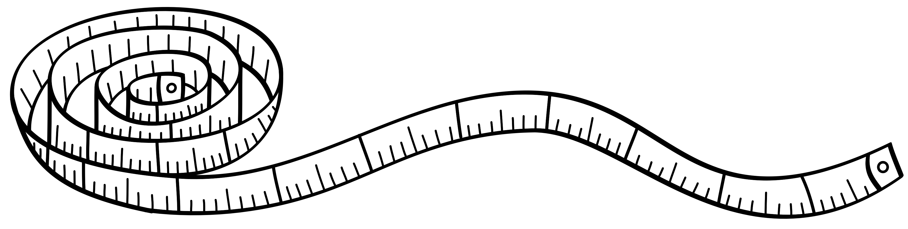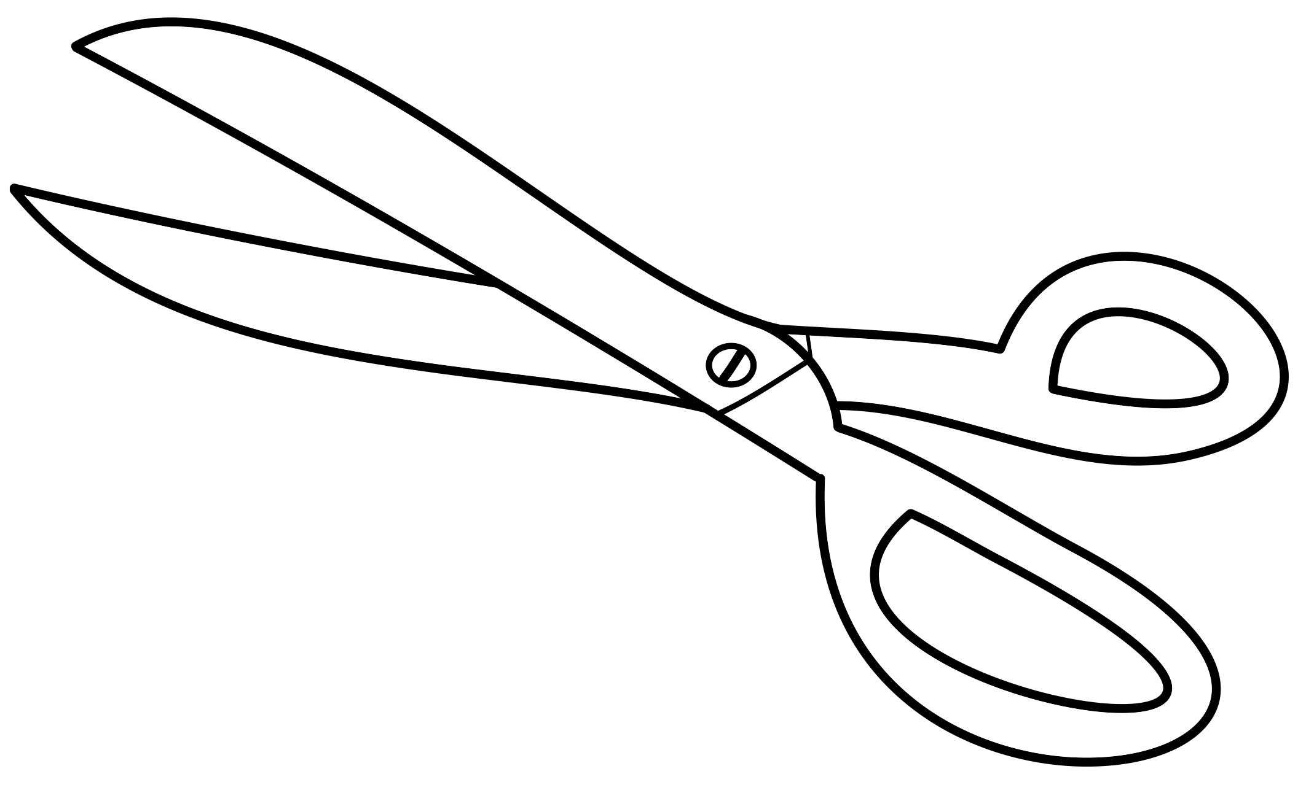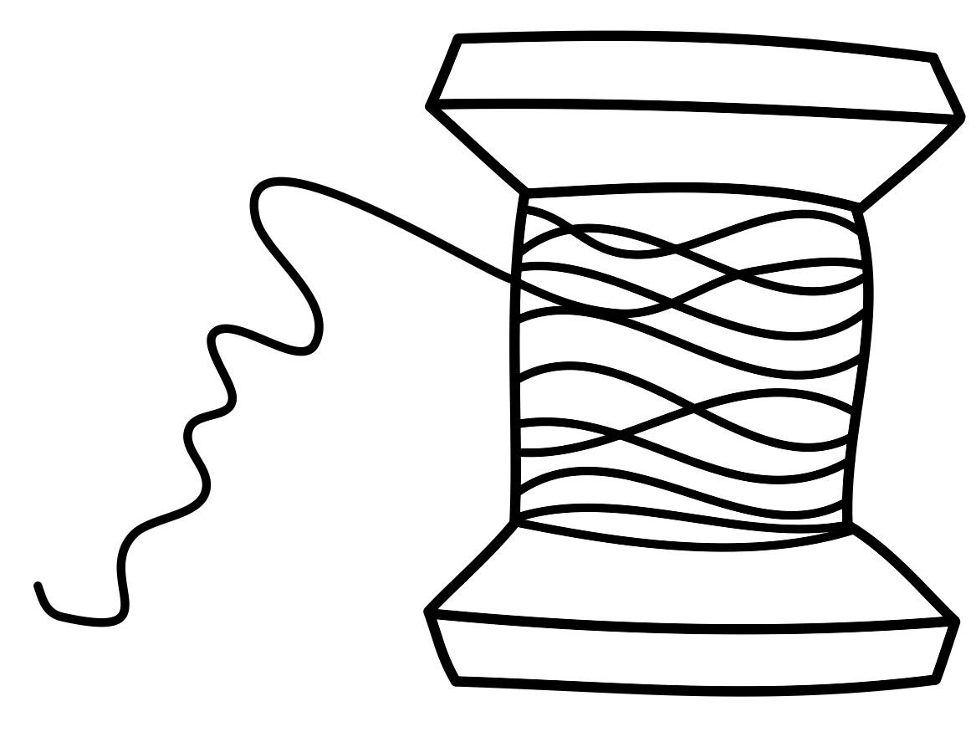

FFA Jacket

Order Form

Please fill out the form and return to Ag Department by: _**Sept. 12th**__

***MUST PURCHASE JACKET AND Tie or Scarf***

Student Name:___________________________________

Tailored (Custom Jacket) $80 Regular Fit (S-3X) $55

Mens Tie $15.50 Womens Scarf $12.50

*You also have the option of purchasing the dress shirt, pants, skirt, and suspenders (female only) from the company if interested please see Ms. Beall for prices.*

The chapter does own a few jackets if you wish to try them on for sizing. Please schedule a time with Ms. Beall.

Office Use Only:

Measurements

Chest/Bust: _______ Waist: _______

Hips: _______ Shoulders: _______

Back Waist Length: _______ Arm Length: _______

Weight: _______ Height: _______

Total Cost:__________________

Payment Method:_______________

Date:_______________