Tarleton National Invitational FFA
Wool & Entomology

Date: May 10th, 2018
When: Tarleton State University Stephenville, TX
Event Check-In 12:30-1:00 p.m. at the Ag Center, Ag Mechanics Building
Contest Begins at 1:30 p.m.
Awards Dinner at 6:00 p.m.

Other Details:
  - A team consist of 4 members
  - Entry fees are $100 per team. (This includes 5 tickets to the award dinner)
  - Anyone can enter, NOT limited to state winners
  - Extra awards dinner tickets may be purchased for $25
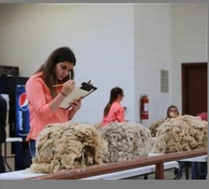
Sign Up TODAY!
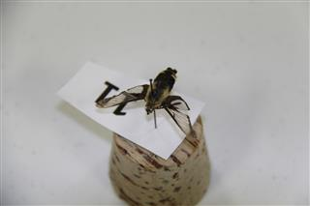
For more information and registration go to judgingcard.com

